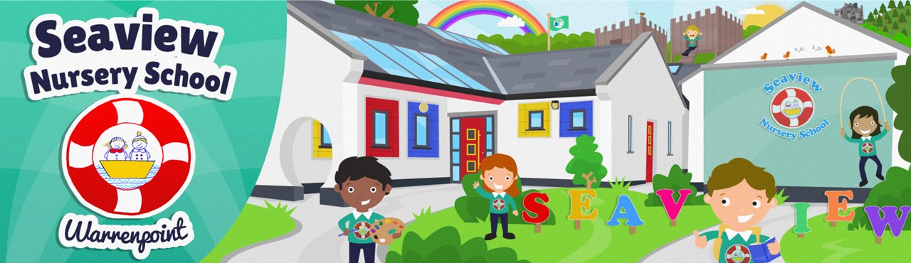

We are delighted to invite prospective pupils and their parents to our

**Open Afternoon**

2-3pm on Monday 13th January 2025

Come and view our amazing facilities and meet our friendly staff!

For further information, please email [info@seaviewns.warrenpoint.ni.sch.uk](mailto:info@seaviewns.warrenpoint.ni.sch.uk)

Or call 028 41753224